37. Hierarchy Custom Setting - 17 July 2021

A Hierarchy is type of custom setting that uses a built-in hierarchical logic that lets you “personalize” settings for specific profiles or users. The hierarchy logic checks the organization, profile, and user settings for the current user and returns the most specific, or “lowest,” value.

Level

1] Org Level

2] Profile Level

3] User Level

ORG Level 🡪 5%

Profile 🡪 15% (Sale Officer)

User 🡪 40% 🡪 (SBI Bank -> System Admin)

Scenario : In Opportunity, there is a field Amount.

1] Create a Field “Discount Amount”

2] Create a field “Discount Percentage”

3] Create a field “Actual Amount after Discount”

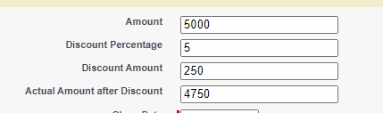

Trigger

Object 🡪 Opportunity

Event 🡪 Before

Operation 🡪 Insert and Update

Object Field to Update 🡪 Opportunity

User 🡪 SBI Bank Profile🡪 System Admin

1] Normal

2] Prime

3] Special

User 🡪 Sheela Profile 🡪 Agent

1] Normal

2] Prime

3] Special

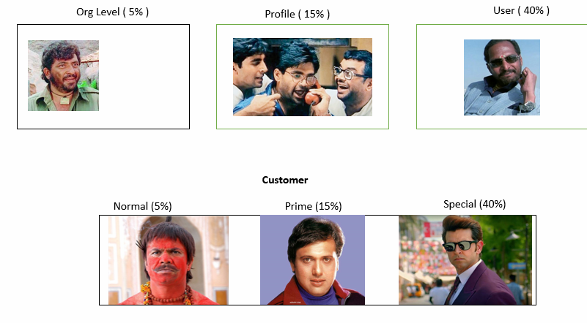

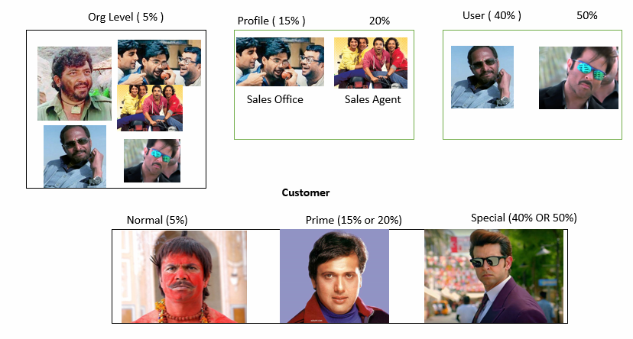

trigger OpportuntiyTrigger on Opportunity (before insert, before update) {

for(Opportunity objOpp : trigger.new){

if(objOpp.Customer_Type__c=='Normal'){

Diwali_Discounts__c diwaliDisc = Diwali_Discounts__c.getOrgDefaults();

objOpp.Discount_Percentage__c = diwaliDisc.Discount_Percentage__c;

objOpp.Discount_Amount__c = (objOpp.Amount*diwaliDisc.Discount_Percentage__c)/100;

objOpp.Actual_Amount_after_Discount__c = objOpp.Amount - ((objOpp.Amount*diwaliDisc.Discount_Percentage__c)/100);

}

else{

if(objOpp.Customer_Type__c=='Prime'){

Diwali_Discounts__c diwaliDisc = Diwali_Discounts__c.getInstance(Userinfo.getProfileId());

objOpp.Discount_Percentage__c = diwaliDisc.Discount_Percentage__c;

objOpp.Discount_Amount__c = (objOpp.Amount*diwaliDisc.Discount_Percentage__c)/100;

objOpp.Actual_Amount_after_Discount__c = objOpp.Amount - ((objOpp.Amount*diwaliDisc.Discount_Percentage__c)/100);

}

else{

if(objOpp.Customer_Type__c=='Special'){

Diwali_Discounts__c diwaliDisc = Diwali_Discounts__c.getInstance(Userinfo.getUserId());

objOpp.Discount_Percentage__c = diwaliDisc.Discount_Percentage__c;

objOpp.Discount_Amount__c = (objOpp.Amount*diwaliDisc.Discount_Percentage__c)/100;

objOpp.Actual_Amount_after_Discount__c = objOpp.Amount - ((objOpp.Amount*diwaliDisc.Discount_Percentage__c)/100);

}

}

}

}

}

**When to use custom setting?**

1. When you are using the same constant value, representing the same thing in more than one formula.
2. Data can be entered by an admin or developer.
3. When you need a different value based on the runtime user or their profile.

**When not to use custom setting?**

1. When you are using same value but it means different things in different formulas.
2. Data needs to be entered by end users.
3. When you need different values based on the record owner or their profile or based on permission set.

**Limits of Custom Settings in Salesforce –**

1. You are unable to share a custom setting object or record.
2. Cached data allowed for you to store in your organization depends on your licenses –  
   – 10 Mb.  
   – 1 MB multiplied by the number of full-featured user licenses in your organization.  
   For example: If your organization has 3 full licenses, you have 3 MB of storage.
3. You can add up to 300 fields per custom setting.
4. No owner is assigned when a custom setting is created, so the owner can’t be changed.
5. Each certified managed package gets a separate limit in addition to your organization limit.
6. Accessing an undeleted custom setting in a formula field results in an error if the user doesn’t have the “Customize Application” permission. To prevent this error, redeploy this custom setting to the organization. Alternatively, delete this custom setting, re-create it with the same name and data, and then delete and re-create all formula fields that use this setting.

To generate PDF, Attachment and Send mail

<https://salesforce.stackexchange.com/questions/280327/apex-class-to-generate-pdf-and-save-it-in-attachement>

<https://sfdcblog.binaryrepublik.com/2019/06/generate-pdf-file-with-apex-trigger-in.html?m=1>

https://developer.salesforce.com/forums/?id=906F000000091SqIAI